**Project Design Phase-I Solution Architecture**

Date Team ID

Project Name

Maximum Marks

16 October 2022 PNT2022TMID31222

Classification of Arrhythmia by Using Deep Learning with 2-D ECG Spectral Image Representation

4 Marks

**Solution Architecture Diagram:**

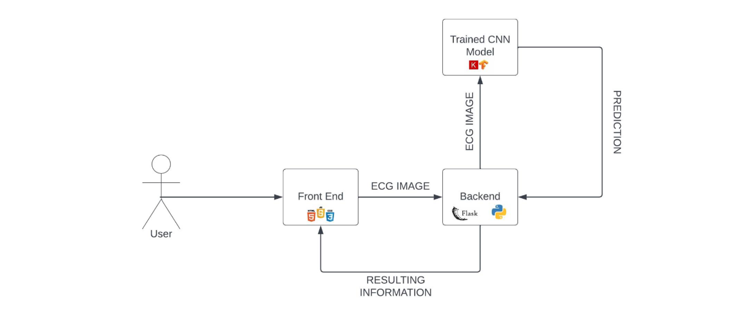

**Technologies needed for Minimum Viable Product deployment**

Upon research, it was found that we need to require the following software technologies for the systematic development and deployment of the project:

• HTML/CSS/JavaScript/Bootstrap – Front End Development • Python

• Tensor Flow

• Image Processing Basics

• Flask – Backend Development

• Git & GitHub – Project Management • IBM Cloud – Hosting

• IBM Watson – Training the Deep Learning Model